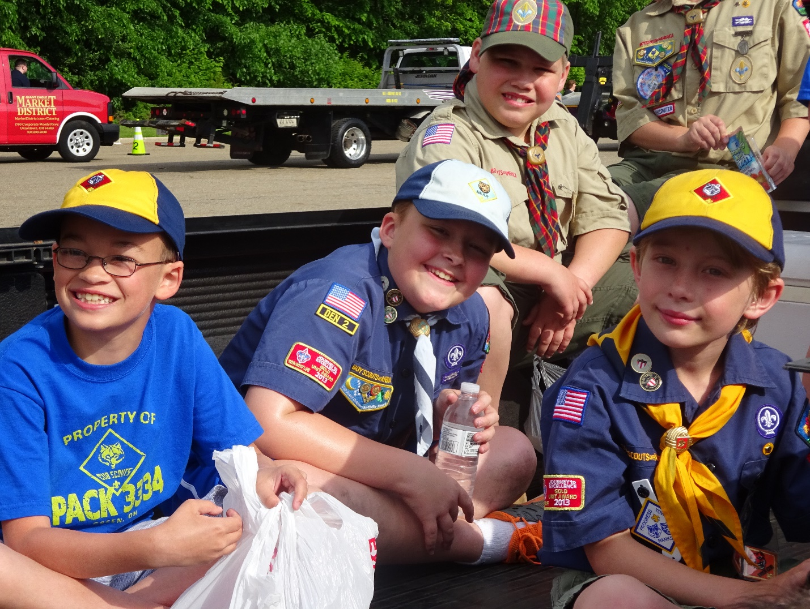
PP PACK 3334

PACK 3334
We are: A Cub Scout Pack for boys aged 6 to 11, and their families.
We meet at: Parish Life Center
Queen of Heaven Catholic Church
1800 Steese Road
Uniontown, OH 44685

We meet: The first, second and third Sundays of the month, at 6:30 p.m.

Contact: Cubmaster@pack3334.org

CONTENTS:
Welcome to Pack 3334 (What Cub Scouting is, meeting times and places) …………
Directory (Cubmaster and Den leader numbers and email addresses) …………
Getting Started (Definitions and scouting terms) …………
Uniforms (What to buy, where to place the patches) …………
Uniform Shopping List (detach and take to Scout Store) …………
Scoutbucks (Incentive program for participation and attendance…………
Advancement (Why is my son doing these activities?) …………
Scoutbook (How to know if your son is on-track) …………
Activities (Our monthly schedule to fun stuff.) …………
Camping (Your guide to sleeping on the ground, or if you’re lucky, a cot.) …………
Fundraising…………
A Parent’s Role (How you can shape your son’s scouting experience) …………
Volunteer Opportunities (Meet other parents! Help the Pack! Get maple syrup in your hair!)

GETTING STARTED
Welcome to Cub Scouting! Now, dress your son in his Class A uniform, send him to the pack meeting at the PLC with his Akela, check in with his den leader, and have him sit with his den for the Bobcat ceremony.
Complete gibberish? Don’t worry. The following definitions will get you started; more definitions can be found on the relevant sections of this book. (See Uniforms, Ranks, Scoutbucks, etc.)
PLC: Stands for “Parish Life Center”. It is the building across the parking lot from Queen of Heaven Church, where regular meetings (and Pancake Breakfasts) are held.
DEN: A group of up to 10 or 12 boys, ranked by age or grade as follows:
Lions: Kindergarten
Tigers: Grade 1
Scouts have the option of joining a den based on age rather than grade. For example, a scout who repeated Kindergarten, or started a year later than his peers has the option of joining a Wolf den when he is in the first grade, if he will be 8 years old by the end of the school year. See the den leaders or the Cubmaster if you have any questions.
Wolves: Grade 2
Bears: Grade 3
Webelos: Grade 4
Arrow of Light: grade 5
(Note: Cub Scouts enter the age-appropriate den at the time they join Cub Scouting. A third grader starting scouting for the first time, for example, would enter the Bear den, and would not go back and earn Tiger and Wolf ranks.)
BOBCAT: First rank every Cub Scout earns, Tigers up, no matter at what age he joins Cub Scouts.
DEN MEETING: Twice-a-month meeting of small group of like-aged scouts to work on advancement goals.
ADVANCEMENT GOALS: Set of accomplishments, different for each rank, that must be achieved to progress. For example, third grade scouts will camp, cook outdoors, hike a mile, and do a service project as part of their requirements to earn the Bear rank.
PACK: All of the dens combined make up the pack. Our pack is Pack 3334; there are two other packs in Green, and dozens of other packs in Summit County.
PACK MEETING: Monthly meeting of all dens of the pack to review pack news, participate in activities, and distribute awards earned the previous month.
COMMITTEE: This is the governing body of the pack. The committee approves all expenditures and appoints groups to plan events.

COMMITTEE MEETING: The Committee meets once a month. All parents are encouraged to attend.

DISTRICT: This is a group of packs, organized geographically. Pack 3334 belongs to the Lakes District in southern Summit County. District events such as Day Camp, Fall Fun Day, Chariot Races, and the District Pinewood Derby draw packs from all over.
COUNCIL: This is a group of Districts and service areas. The Lakes District belongs to the Great Trail Council. (See http://www.gtcbsa.org/districts/). The Great Trail Council organizes Adventure Camps and other council-wide activities.
CHARTER ORGANIZATION: The non-profit that hosts the pack and provides a place for it to meet. Our charter organization is Queen of Heaven church.
AKELA: Anyone who acts as a leader to the scout, eg., Parent, Cubmaster, Den Leader.
DEN LEADER: A trained adult in charge of running a den. Your den leader should be your first point of contact when you have a question about our pack.
ASSISTANT DEN LEADER: Trained adult who assists the den leader.
DEN CHIEF: Boy Scout who helps the den leader during meetings.
CUBMASTER: The person who guides the pack. Den leaders report to the Cubmaster.
TROOP: Refers to a group of Boy Scouts; is not used in Cub Scouting.

UNIFORMS
You show up to the PLC for the first Pack meeting. Everyone seems to be wearing something different. Blue shirts, tan shirts, different colored caps and handkerchief-thingies around their necks.
There are patches on all the shirts – good lord, do they sew those on??? And some boys are running around with red vests.
Uniforms help Cub Scouts take pride in their pack and identify as a unit.
Uniforms are available from the Scout Shop, 1601 S. Main St., Akron
For hours, visit http://www.gtcbsa.org/scoutshop/
or call 330-773-0415.
All scouts need a “Class A uniform”: A cap, neckerchief, and slide with the rank color and emblem, and a uniform shirt and belt.
Lions have their own Lion shirt & hat
Tiger, Wolf, and Bear scouts wear blue shirts.
Webelos scouts can continue to wear the blue shirts, or they can start wearing the tan shirts they will wear as Boy Scouts.
(Please note: our pack does not require uniform socks or uniform pants. The Pack will provide the Pack Number (3334) patch.
Scouts wear Class A uniforms to meetings and activities unless otherwise notified. The Pack offers a Class B uniform – a blue-t-shirt with our Pack logo -- for outdoor events such as cookouts and hikes.
Wearing your uniform pays! We award “Scoutbucks” for being on time and in uniform. Scouts spend these at our annual auction. See the “Scoutbucks” page for more details.
PATCHES
Some patches are an important part of the Class A uniform, and others signify accomplishments and are not worn on the uniform itself.
You will need to buy the following patches for the Class A uniform: Great Trail Council patch, den number (see your den leader), and World Crest. (See following pages for placement information.) Other patches will be provided by the pack, as your son earns them.
You do NOT buy the rank badges – the diamonds with the Bobcat, Tiger, Wolf, or Bear in them. The pack provides these as the scouts advance.
When Tiger, Wolf and Bear scouts finish one of their “Adventures” (advancement goals), they earn an adventure belt loop – a decorative metal loop that is strung like a bead on a scout’s belt.
Webelos receive pins instead of belt loops. These are worn on the Webelos colors (flat woven cords hanging from sleeve) or on the front of the cap.
Scouts earn awards and activity patches by participating in pack activities and earning awards. The patches are attached to red Brag Vests, which are worn at pack meetings. The pack has a limited supply of Brag Vests; ask your den leader if they are available. Brag Vests can also be purchased at the Scout Shop.
We never want a boy to be excluded from scouting because of financial concerns. Our pack maintains a “campership” fund to help families who need assistance with costs related to scouting.
Here is a guide to patch placement. Patches can be sewn on to uniforms or brag vests, or attached with a product called “badge magic”. http://www.badgemagic.com/.
Not all patches continue to be worn as your scout advances. It’s a good idea to google “Patch Placement” to determine which patches are permanent and which ones will need to be removed, and to pin or sew the removable ones rather than glue them on.
Cub Scout Patch Placement: Uniform Sleeves
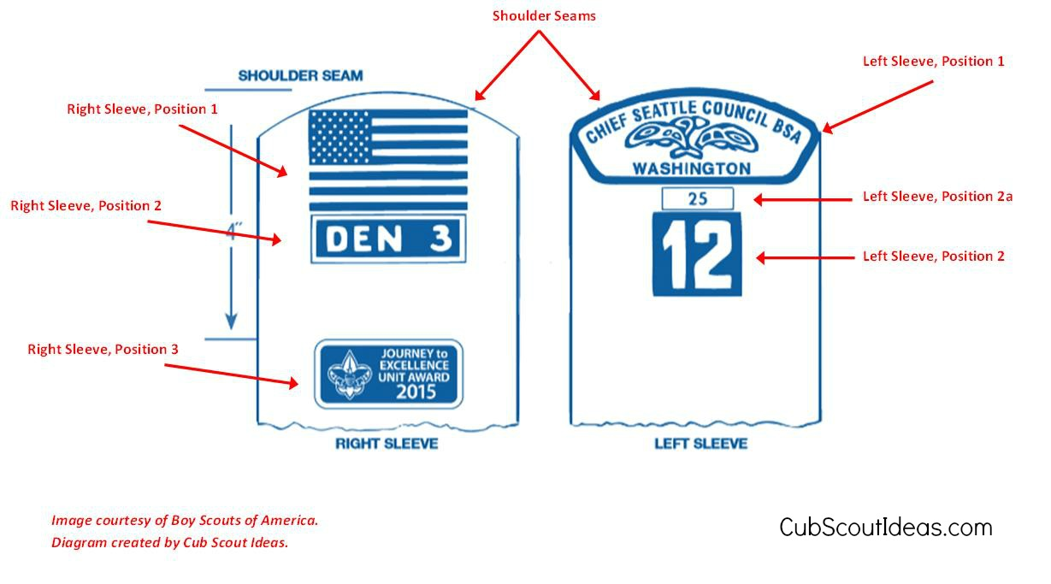

Left Sleeve Cub Scout Patch Placement
At the very top along the shoulder seam, place the Great Trail Council shoulder emblem.
(position 1)
Next, in position 2 above, is our PACK NUMBER: 3334. You should get this from the pack leader.

Right Sleeve:
New uniforms come with the American flag in place. If the patch has been removed, you can attach it to the right sleeve of the uniform (position 1) The den number goes below the American flag (position 2). Ask your den leader for this number; it will remain the same through your son’s time with our pack.
If the pack gives you a Journey to Excellence patch, attach it below the den number on the right sleeve at position 3.

Cub Scout Patch Placement: Front of Uniform
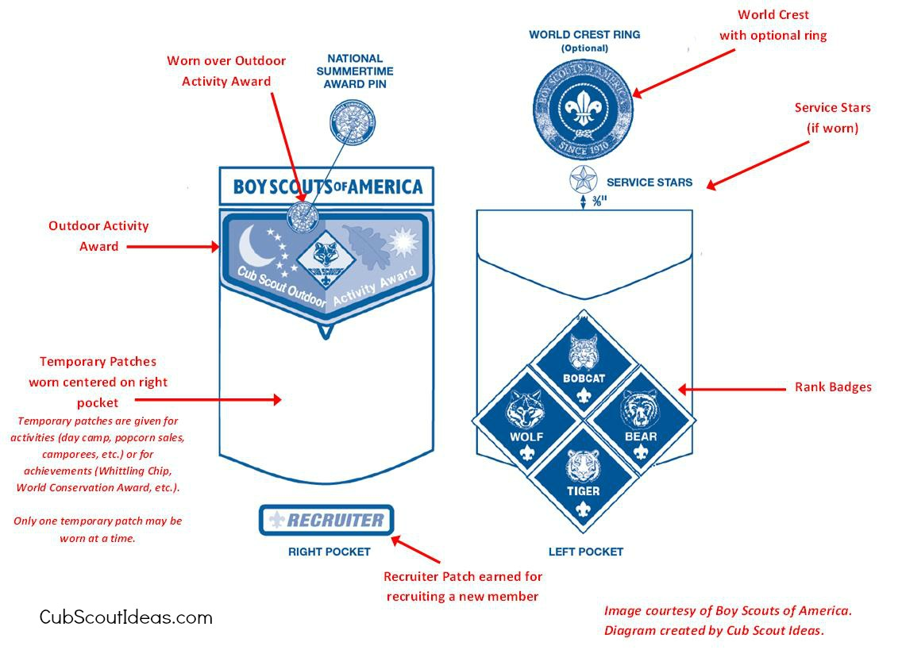

Left Pocket Cub Scout Patch Placement
The World Crest is worn above the left pocket. It is centered between the left shoulder seam and the top of the left pocket. It signifies that the Boy Scouts of America is part of the World Organization of the Scout Movement.
The badges of rank – provided by the pack as your scout advances – go on the left pocket as shown in the image above. (The scout store sells plastic sleeves that hook on the pocket button and hold the four patches.) Rank badges are placed in the order shown above.

Right Pocket Cub Scout Patch Placement
If your scout earns an Outdoor Activity Award patch, it goes on the right pocket flap. Pins earned for the Summertime Pack Award are pinned onto the Outdoor Activity Award patch.
Temporary patches can be hung on the right pocket button via the patch’s button loop. Only one temporary patch can be worn at a time.
If your son earns the Recruiter patch, it is worn directly below the right pocket.

SCOUTBUCKS
Your son enjoys scouting – but sometimes it’s hard to pry him away from his friends and get
him to meetings.
That’s where Scoutbucks come in.
Scoutbucks is an incentive program for scouts to get into their uniforms and out to the car. Scouts earn Scoutbucks each time they attend meetings, participate in non-meeting activities, and wear their uniforms.
At the end of the school year, scouts use their Scoutbucks at our annual auction, to bid on toys, games, knives, camping and fishing gear, etc.
Parents can earn Scoutbucks for their sons by volunteering.
The Cubmaster keeps the Scoutbuck ledger based on reports from Den Leaders.
The Scoutbucks program runs during the school year. Scouts don’t earn Scoutbucks for summer activities – but they can earn some pretty cool patches and summertime activity awards.
Here are ways to earn Scoutbucks (valid as of March 2016; incentives may change):
Attend a Den Meeting on time
Wear uniform to Den Meeting
Attend a Pack meeting on time
Wear uniform to Pack Meeting
Participate in 12 non-meeting Scouting activities (See “Activities”.)
Parent volunteers 12 times per year* (see “Volunteer Opportunities”)
Parent volunteers as Den leader or Assistant Den leader
Parent volunteers as Popcorn Kernel

*Actively participating on the Pack Committee counts as five credits towards the total of 12.

ADVANCEMENT: THE OVERALL PICTURE
You’ve bought the uniform and learned the lingo; now you go to meetings, where your son does different activities. Some make sense, some seem completely random.
What’s going on?
When a boy joins scouts, he is assigned to a different den based on his age: Tigers, Bears, Wolves, Webelos, and Arrow of Light.
These aren’t just labels for different age groups. Each den is named after the rank the scout is working to earn.
Scouts earn ranks by completing “Adventures”, groups of three or more required activities.
While the scout is concentrating on each activity, he is absorbing lessons from the Scout Law.
For example, in the “Bear Claw” Adventure, third-grade boys learn about knives, knife safety, and first aid, and carve two items. Without realizing it, they are learning to be responsible, to plan before they act, and to be aware of people around them.
Each rank program is designed to cover one year, from June through May. (Boys may join at any time during that period.)
Detailed descriptions of advancement requirements can be found in the Scout Handbook. available at the scout shop at 1601 S. Main St. (Akron). Visit http://www.gtcbsa.org/scoutshop/ or call 330-773-0415 for hours.

Our pack meets officially from September through May. At these meetings, we work on advancement requirements.
Scouts may also complete requirements on their own.
Most scouts advance at a ceremony in February or March, although some scouts may need to advance in May.
Once a scout advances, he can earn awards by working on more non-required adventures. Scouts don’t work on their next rank until the school year ends.
A note on Cyber Chips: All ranks require that scouts earn their “Cyber Chip,’ a program designed to protect children from online predators.
The Cyber Chip requirement may be waived by the scout’s parent or guardian, if internet access is not available at home, school, or another public place.
Complete cyber chip exercises at: www.scouting.org/Training/YouthProtection/CyberChip.aspx

SCOUTBOOK
Okay, you kinda, sorta, maybe understand the basic idea behind advancement – your son needs to do a bunch of activities to earn his rank.
But how does the den leader keep all of this straight? To advance to Bear rank, for example, each boy has to do a minimum of 38 different activities. That’s hard enough to record for one scout, let alone eight, some of whom might miss any given meeting.
Fortunately, we have Scoutbook, an invaluable online resource. The application, at www.scoutbook.com:
- Helps den leaders keep track of each scout’s progress.
- Helps the Cubmaster keep track of the entire Pack’s progress.
- Helps parents see how close their son is to advancing, what he still needs to do, and whether he has been credited for awards he has earned.
Your son will be entered into Scoutbook soon after he registers with our Pack. You will receive an invitation to join Scoutbook shortly afterwards.
Your son’s account will be visible only to you, pack and den leaders, and anyone with whom you share the account.
Once you’re invited, go ahead and experiment.
Create a profile. Click on your son’s page, then his “advancement” link, then his current rank. You should wind up on the page where his advancement requirements are recorded.
New scouts earn their Bobcat rank, and the rank that fits their age. They do not have to go back and earn any previous ranks.

The den leader is responsible for recording each scout’s advancement.
However, several requirements are designed to be done at home. You must either record them in Scoutbook yourself, or notify the den leader when a requirement is completed.
You should have the ability to record an achievement, but not approve it.
Den leaders are human, and Scoutbook isn’t perfect. If you see your son didn’t get credit for a requirement, please bring it to his den leader’s attention.
In addition to requirements, you can record the miles your son hikes, the times he goes camping, and the service projects he does.

ACTIVITIES

Enough about the mechanics of scouting. Your son joined scouting to have fun – and Pack 3334 offers a lot of it.
Cub Scouting offers an event almost every month. Almost all events are open to parents and siblings 11 years old or younger; many are open to older siblings, too.
Here is a sample of activities offered by our Pack, the District, and the Council in the 2015-16 scout year. Some require a fee; many offer a patch for participation.
SCHEDULES ARE SUBJECT TO CHANGE FROM YEAR TO YEAR. However, most of these opportunities are offered annually.
For descriptions of activities, please see the “Pack 3334 Adventures” handout.

June:
Fellers Cake-Off
Fishing Derby
Rocket Launch
Flag Retirement Ceremony
Rubber Ducks game and campout

July:
Miniature Golf
Day Camps (All dens)
Resident Camp (Webelos)

August:
Pack Picnic
Queen of Heaven Summer Activity

September:
Pack Campout
Adventure Camp
St. George Cub Scout Day
Hiking Spree (Sept.- Nov.)
Popcorn Sales

October:
Fall Fun Day
Haunted Hayride
Costume meeting
Popcorn Sales

November:
Cub College
GPS Uniform Day/Veteran’s Day Ceremony

December:
Pack Bowling
Pack Christmas Party
Breakfast with Santa
January:
Camp-in at the PLC
Chariot Race
Lake Erie Monsters Scout Day at the Q

February:
Blue and Gold Banquet
Scout Sunday
Scout Day at MAPS museum
Scout Ski Day

March:
Pinewood Derby
Canton Charge Scout Night

April:
Cavaliers Scout Day at the Q
Bring Your Bike to Boettler

May:
Veteran’s Grave Decoration
Memorial Day Parade
Adventure camp
Scout Buck Auction
CAMPING
The word “camp” comes up often in scouting, and in many different contexts. Take a moment to get familiar with the various camps that are offered.
Medical forms must be submitted for ALL camp participants, including scouts, sibling tagalongs, and parent participants and volunteers.
DAY CAMPS
No sleeping overnight for Tigers through Bears. These “camps”, held in July, offer day-long activities, often meeting rank requirements. Wolf, Bear and Webelos/Arrow of Light scouts must bring lunch.

Siblings of scouting age may participate in all of these camps. All camps require some parent volunteers to run stations and walk scouts from station to station.
The pack uses Pancake Breakfast funds to reimburse parents for at least some of the costs of these camps; There usually is a discount for signing up early.
Tiger: Half day. Parents must attend.
Wolf and Bear: Three days, parents drop off and pick up scouts.
Webelos/Arrow of Light: Three days, parents may drop off scouts. Family overnight campout after last day.
OVERNIGHT CAMPS
Unless otherwise noted, scouts must camp with adult guardians; no scout is allowed in the tent of a non-relative. Siblings are welcome at all camps except Resident Camp.
ADVENTURE CAMP: One-night camp held at Camp Butler or Camp Manatoc in September and May. The Pack takes applications and registration fees. Includes snacks, campfire ceremony and skits on Friday night; breakfast, lunch and activities through Saturday afternoon.
PACK CAMPOUT: One-night campout held by our pack in August or September, followed by a day of activities. Scouts may come for the campfire, campfire and camping, or campfire, camping, and activities.
RESIDENT CAMP: Three-night overnight camp in July for Webelos and Arrow of Light Dens. Scouts sleep in two-man tents with another scout. By day, they work on requirements for their rank. Scouts must pass swim test to use portions of the pool.
Parents not required to attend, but adult volunteers are necessary.
RUBBER DUCKS/CANTON CHARGE OVERNIGHTERS: Watch a baseball/basketball game, then camp overnight on the field or court. Includes movie and activities.

FUNDRAISING
Lingo, check. Uniform, check. Basic understanding of scouting, check.
You settle in to your first pack meeting, confident you know most of the basics. Suddenly, this person starts leading a pep rally about selling popcorn, then someone else starts asking for volunteers for the pack’s pancake breakfasts.
Gulp. They want your son to sell stuff? And what’s up with the pancake breakfasts? Shouldn’t your son’s membership fee cover everything?
Not quite. Part of each scout’s membership fee goes to the Great Trail Council, which provides facilities and services to packs throughout most of Summit County.
The rest covers some of the cost of patches, belt loops and pins, but the pack still has costs to cover: Supplies, food for events, training costs, facility fees, neckerchiefs for veteran scouts, etc.
The pack is led entirely by volunteers. Nobody gets paid. To offset the costs to parents of activities and awards, our pack raises funds with popcorn sales, pancake breakfasts, and aluminum can recycling. Here’s a quick overview of each:
POPCORN
Popcorn sales are by far the biggest source of funds for our pack. Scout packs and troops keep 1/3 of the retail price of every package of popcorn sold. In 2015, this amounted to more than $7,500 for our pack.
There are four basic ways to sell popcorn. You’ll hear about them in lots of emails. Here is your cheat sheet to the terminology:
TAKE-ORDER: (Late August to Nov. 1): You and your scout take orders from coworkers, neighbors, families, and friends. You turn in the orders to the “Popcorn Kernel” on Nov. 1. You deliver the popcorn in mid-November.
SHOW AND SELLS: (mid-Sept. to late-Oct.): Two scouts and their parents sell the popcorn at the entrance to a local business.
SHOW AND DELIVERS (Mid Sept. to late Oct.): A group of scouts and their parents take popcorn out to neighborhoods and sells it directly to residents. (No taking orders, no delivery!)
ONLINE SALES: You will receive an online account, from which your out-of-the-area friends and relatives can buy from your son. A shipping charge is added to these sales.
Scouts can earn many prizes and incentives for meeting certain goals – starting with a patch for selling just one item. Prizes, incentives, and tips on how to sell effectively are discussed at the first pack meeting.
The prizes are nothing compared to the lessons your son will learned from selling popcorn. His confidence in talking with adults, his realization that constant hard work yields big rewards, and his ability to keep going in the face of rejection is something he will buildt one sale at a time.
PANCAKE BREAKFASTS
On the first Sunday of every month in the school year, the pack holds a pancake breakfast targeted at the people getting out of mass at about 9:15 a.m.
We’re downright nefarious about it – we cook bacon, eggs and pancakes in the PLC kitchen, and when the parents drop off their children for Sunday school, the delicious smell all but forces them to fork over $5 for a plate of food.
We always need parents to cook and serve the food, and scouts in uniform to wipe tables and bring extra pancakes and coffee to our customers.
After expenses, we raise about $1,700-$1,900 a year from these breakfasts. All of that money goes towards defraying the cost of day camp for our scouts.
ALUMINUM CAN COLLECTION
We help our pack, the environment, and the Ronald McDonald House with our can collection program.
Scouts bring in crushed cans, which are stored at a volunteer’s house. They bring in the pop tabs to the cans separately – the tabs are donated to the Ronald McDonald House.
Our pack gets funds, our boys learn environmental responsibility and generosity.
If you have a large garage or storage shed, please consider being the Can Collection Colonel: You would store all cans collected by the pack and bring them to the recycling facility.

A PARENT’S ROLE
As a parent, you are the most important influence in your child’s life. Scouting can do wonderful things for your children, but only with your support and guidance.
Our pack offers something for the entire family:
- Almost all activities are open to all family members.
- Day camps and Cub College are open to siblings of scouting age.
Parents of Tigers must attend meetings with their scout. Parents of any other rank are not required to, but are encouraged to do so as well.
There’s a lot you can do to make sure your son’s experience in scouting is a good one:
COME EARLY: Nobody likes to be the last in the room when the meeting is going!
COME OFTEN: The more meetings your scout attends, the less he has to make up.
STAY IF YOU CAN: Two adults must be present at all meetings and activities. You may be asked to help with meetings.
SET A GOOD EXAMPLE: If you attend, please listen quietly.
WORK AT HOME: Some requirements are designed to be done at home.
COMMUNICATE: Keep the den leader informed of your son’s progress on his requirements, either through email or Scoutbook. Let the leader know if your son needs to skip a meeting, or is experiencing any issues that keep him from enjoying scouting.
READ EMAILS: Read all emails from the Pack or your Den Leader. Let your leaders know if you prefer another way to be contacted. RSVP promptly to invitations.
VOLUNTEER: When you volunteer, your son gets a lesson in how to give back to the community – and he may get Scoutbucks to spend at the annual auction. (See “Scoutbucks” page.) Please see “Volunteer Opportunities” sheet for ways you can contribute your talents to the pack.
HELP WITH FUNDRAISERS: See “Fundraisers” page for how you can help the Pack provide the best possible program at the lowest possible cost for all scouts.
PARTICIPATE!: Pack and Den meetings should be fun – but it’s activities like rocket launches, chariot races, camping and day camps that the boys really love. Bring your son to as many as possible, and your boy will feel part of a fun, meaningful group.

VOLUNTEER OPPORTUNITIES

Without volunteers, our Pack would stop operating overnight. Your generosity with your time and talent allows us to provide the best possible program at the lowest possible cost for your son.
Volunteering helps you meet other parents in the pack. And, you can earn Scoutbucks for your son by volunteering 12 times in one school year.
Below are the positions we need to fill, sometimes monthly, sometimes yearly, sometimes every few years:
LEADERSHIP
(Training and background check required.)
CUBMASTER: Plans and leads monthly Pack meetings; works with the Committee on recruiting new scouts, planning fun activities, and getting funding for the program. Works with den leaders to plan events and make sure they are providing effective and fun den programs for the scouts. Makes sure the overall Pack follows BSA policies.
ASSISTANT CUBMASTER: Works with the Cubmaster.
DEN LEADER: Plans fun meetings that fulfill advancement requirements. Records advancement in Scoutbook, communicates with parents, may delegate activities and meetings to individual parents.
ASSISTANT DEN LEADER: Works with Den Leader to provide exciting, educational program to the boys.
COMMITTEE
(Training/background check required)
COMMITTEE CHAIR: Runs the pack committee, approves bills, acts as liaison between pack and chartering organization, oversees and runs operations of the Pack.
COMMITTEE SECRETARY: Maintains the attendance, provides forms and records to Pack leaders, records notes on meetings, keeps inventory of Pack property, notifies membership of committee meetings, and handles correspondence for Pack.
COMMITTEE TREASURER: Helps establish and enforce budget, oversees finances, handles checkbook, collects dues, keep records of dues and payments.
COMMITTEE MEMBERSHIP AND MARKETING CHAIR: Works with Cubmaster and committee to recruit and retain Scouts.
COMMITTEE MEMBER: Attends committee meetings; reports on how program is progressing from scout’s perspective, votes on issues and plans activities.

NON-LEADERSHIP POSITIONS
POPCORN KERNEL: Plans and runs the pack’s most important fundraiser. Orders product from Council, arranges public sales of popcorn, distributes popcorn and sales materials to boys, balances books, communicates with parents, committee, and council.
BLUE AND GOLD PLANNING TEAM: Chooses theme and plans menu, decorations, and program for annual Blue and Gold Banquet, held in February.
CUB COLLEGE “PROFESSOR” Parent who teaches a 20-minute class to several groups of scouts at Cub College, usually in November. The college is designed to help boys meet adventure requirements; professors get a 50 percent discount on tuition.
PANCAKE BREAKFAST VOLUNTEER: Parent who cooks or serves pancakes, eggs, or bacon at monthly fundraiser. Money from Pancake Breakfasts go to defray cost of day and/or residence camp for all scouts. Shifts run from 8 a.m. to about 11 a.m. the first Sunday of the month during the school year. It’s a great way to meet other parents.
CHARIOT DECORATOR/COSTUMER Den leaders rely on parents to help come up with a theme and costumes, and to decorate the cardboard box for the annual Chariot Race held in January. (See “Pack 3334 Adventures!” for description of chariot race)
FISH FRY SET UP: Sets up dozens of tables and hundreds of chairs for Queen of Heaven’s six weekly Friday Fish Fries during Lent. It takes roughly one hour per shift.
DAY CAMP WALKAROUND (Youth protection training required): Parent who takes a group of six to 10 boys from station to station during one, two, or three-day summer day camps in July. Walkarounds work in groups of two or three.
DAY CAMP COUNSELOR (Youth protection training required): Parent who runs a station during day camp, running one activity. Siblings aged 11 years and older may also help. Day Camp also has a need for medical volunteers daily to be ready for any medical issues that might occur.
ALUMINUM CAN COLLECTIONS: Every year, the pack collects aluminum cans, and recycles them to fund activities.
PINEWOOD DERBY COMMITTEE – Help organize the Pinewood Derby, check derby cars for proper construction, help set up and tear down the Pinewood Derby event.
In addition, help is typically needed for other events such as the Pack Picnic, , Fall Fun Day, or other Pack activities. We often ask parents to bring food items for various pack events.

